Exercise 6: Library Management System

Search Algorithms

Linear Search
- Checks each item in the list one by one until the desired item is found or the list ends.
- Works on unsorted data.

Binary Search
- Repeatedly divides the sorted list into halves to find the item.
- Works only on sorted data.
Output
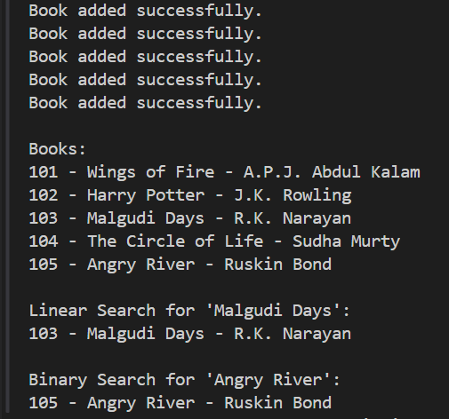

Time Complexity
- Linear Search – O(n):
Goes through each book until it finds the match.
- Binary Search – O(log n):
Cuts the search space in half each time, faster for large sorted lists.

When to Use
- Use Linear Search:
When data is small or unsorted.
- Use Binary Search:
When the list is large and already sorted.

